NASTP Institute of Information Technology


Submitted To: Sir Hammad

Submitted By: Huzaifa Hassan

Rollno : S2025AI036

Semester: 4th Semester – Fall 2026

Subject: AI LAB

- Objective
The objective of this laboratory session is to apply fundamental Python data structures, functional modularity, and concise sequence operations:
- Constructing a hash-mapped frequency analysis table using standard string tokenization and dictionary manipulation methods.
- Implementing iterative linear filtering on sequence collections using conditional predicates.
- Managing multi-dimensional, nested data structures (dictionaries mapping to lists) and aggregating numerical values via specialized functions.
- Implementing declarative data filtering techniques using Python list comprehensions within reusable function blocks.
2. Theory
2.1 String Tokenization and Hash Maps (Dictionaries)
In Python, strings are immutable sequences. The .split() method tokenizes a string based on whitespace delimiters (or specified separators), returning a list of discrete substring tokens in $O\left(N\right)$ time, where $N$ represents the string length.
Frequency aggregation utilizes the built-in dict type, which is implemented internally as a dynamic hash table. Associating unique tokens as keys and their occurrences as values enables $O\left(1\right)$ average-time complexity for insertions, updates, and lookups:
$$\text{count}\left(w\right)←\text{count}\left(w\right)+1$$
Using the .get(key, default) method prevents runtime KeyError exceptions by providing a fallback default value (typically 0) when a key has not yet been registered in the dictionary.
2.2 Linear Filtering via Definite Iteration
Filtering extracts a subset $S'⊆S$ whose elements satisfy a boolean predicate $P\left(x\right)$:
$$S'=\left\{x∈S∣P\left(x\right)=\text{True}\right\}$$
In procedural iteration, an empty accumulator list is populated sequentially using .append(). Each element from the source list is checked against the relational condition ($x>0$), executing in $O\left(N\right)$ linear time and requiring $O\left(K\right)$ auxiliary space, where $K$ is the number of elements satisfying the predicate.
2.3 Nested Data Structures and Aggregation
Complex data modeling often requires hierarchical structures, such as a dictionary where keys are strings (identifiers) and values are numerical sequences (list of int or float).
Calculating statistical aggregates involves:
- $\text{Summation: }\sum_{i=1}^{n}{x_{i}} \text{via }sum()$
- $\text{Cardinality: }n \text{via }len()$
- $\text{Arithmetic Mean: }μ=\frac{1}{n}\sum_{i=1}^{n}{x_{i}}$
Encapsulating this logic inside a parameterized function establishes modular code reuse and separates data definitions from computational processing.
2.4 Declarative Filtering via List Comprehension
List comprehension provides a syntactically concise, optimized mechanism for generating lists from existing iterables:
$$[expression for item in iterable if condition]$$
At the bytecode level, list comprehensions execute inside an optimized C-level loop construct (LIST_APPEND), avoiding the overhead of repeatedly resolving the .append() method attribute in the Python interpreter. An integer $n$ is classified as even if it satisfies the modulo congruence:
$$n \left(mod 2\right)≡0$$

3. Tools / Software / Libraries
- Language: Python 3.x
- Development Environment: Visual Studio Code / Jupyter Notebook / Terminal
- Libraries: Standard Built-in Python Runtime (no external dependencies required)
4. Procedure / Methodology
- Word Frequency Counter (Task 1):
  - Read an input sentence string.
  - Decomposed the sentence into constituent word tokens using .split().
  - Initialized an empty dictionary frequency_dict = {}.
  - Iterated over the tokenized list; updated word occurrences using the dictionary .get() method.
  - Formatted and displayed the key-value mappings.
- Positive Number Extractor (Task 2):
  - Initialized a list of signed integers.
  - Created an empty accumulator list positive_numbers = [].
  - Iterated across the source list using a for loop.
  - Evaluated each integer against the predicate num > 0; appended passing values into the accumulator list.
  - Displayed the filtered output list.
- Student Average Calculator (Task 3):
  - Initialized a dictionary mapping student name strings to lists of numerical grades.
  - Defined the function show_student_averages(student_records).
  - Iterated over dictionary items via .items().
  - Evaluated the arithmetic mean for each student by computing sum(marks) / len(marks).
  - Printed the formatted names and calculated averages.
- Even Number Extractor Function (Task 4):
  - Defined get_even_numbers(numbers).
  - Implemented a list comprehension applying the modulo predicate num % 2 == 0.
  - Returned the resulting list of filtered integers.
  - Executed a test call with a sample list and displayed the returned output.

5. Observations
- The .split() method automatically handles variable lengths of consecutive whitespace, preventing empty string entries during word extraction.
- Using dict.get(key, 0) eliminates explicit if key in dict membership pre-checks, simplifying the frequency accumulation logic.
- List comprehension executes filtering with fewer lines of code and lower interpretive overhead than manually structured accumulator loops.
- Performing sum() and len() on nested lists requires guarding against empty lists (len(marks) == 0) to prevent ZeroDivisionError exceptions.
6. Analysis / Discussion
- Hash Table Performance: In Task 1, storing tokens in a Python dictionary offers an average insertion and lookup complexity of $O\left(1\right)$. Total execution time scales linearly as $O\left(N\right)$ with respect to the total word count, providing efficient indexing for text preprocessing pipelines.
- Predicate Filtering: Task 2 and Task 4 address the same algorithmic pattern—filtering a sequence against a boolean condition. Task 2 uses an explicit imperative loop with step-by-step state modifications, whereas Task 4 uses a declarative list comprehension. List comprehensions generate specialized C-level bytecode instructions, making them faster than repeated Python-level .append() method invocations.
- Compound Data Structures: Task 3 illustrates how relational data is modeled without external database libraries. Coupling dictionary iteration via .items() with sequence aggregation functions (sum() and len()) cleanly separates key-based indexing from numerical processing.
7. Conclusion
The laboratory exercises demonstrated fundamental Python data management techniques. Word tokenization and hash-based frequency aggregation were implemented using dictionaries. Linear filtering was evaluated through procedural iteration as well as optimized list comprehensions. Finally, nested structures were processed modularly using custom functions, completing the core data structure requirements for the course.

Task 1
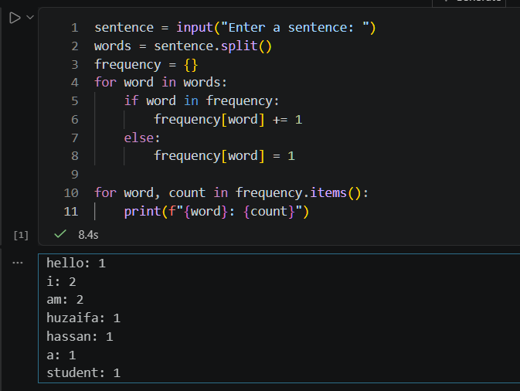
Task2
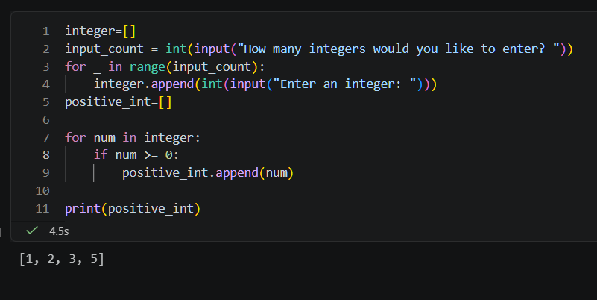

Task 3
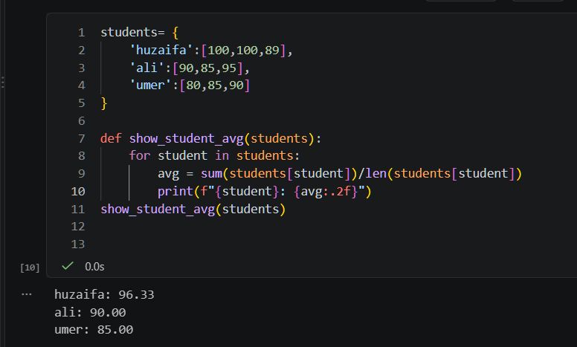

Task 4
